|  |  |  |  |  |  |  |
| --- | --- | --- | --- | --- | --- | --- |
| Test Case Scenarios | R24.4 – PEPP VPB Minimum Payments (AGE 72) Report ITA Minimum Factor Incorrect | | | | | |
| JIRA # | PEPP-4358 | | | | | |
| Creation Date | 23-Oct-20 | | | | Tester Name | Janette |
| Environment | Penfax5 | | | Test | **Release version** | 24.4 |
| Software Used | Microsoft Edge | | | Version: 44.18362.449.0 |  | |
| System Area Affected | | Document Production | | | | |
| **Test Case** | | | | | | |
|  | **Test #** | | **Test Description** | | | |
| N/A | | The ITA Minimum Factor for calculating the minimum payments for VPB members turning Age 72 is incorrect. | | | |
| Expected Outcome | The report should be pulling the ITA Minimum RRIF Withdrawal Factors to calculate the minimum withdrawal for members turning age 72 in the current year. | | | | | |

**Specify all Test Case Step with screenshots in order to recreate the defect**

**Test #:**

**Defect Description:** The ITA Minimum Factor for calculating the minimum payments for VPB members turning Age 72 is incorrect.

**Steps:**

1. Go to Batches 🡪 Add Batch Process 🡪 Batch Process Type = PEPP VPB Minimum Payment (Age 72) Report and click Save.

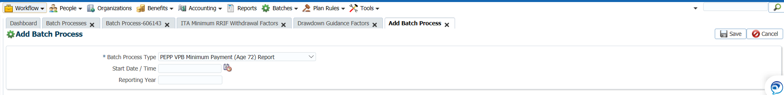

1. Click on the Batch Process ID, then Files and then click the file and select Open.

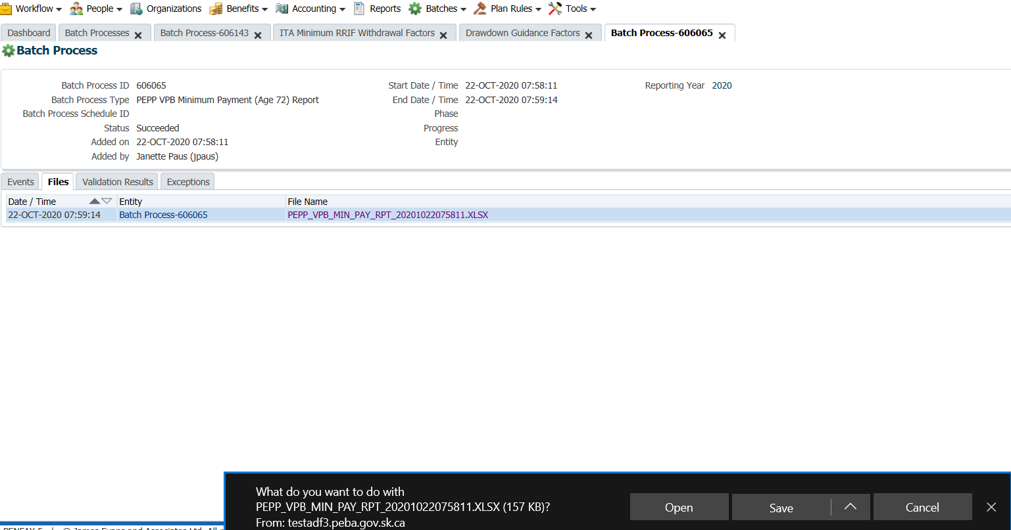

1. The New Age Factor should be pulling from the ITA Minimum RRIF Withdrawal Factors:
   1. Go to Plan Rules 🡪 Federal Government 🡪 ITA Minimum RRIF Withdrawal Factors

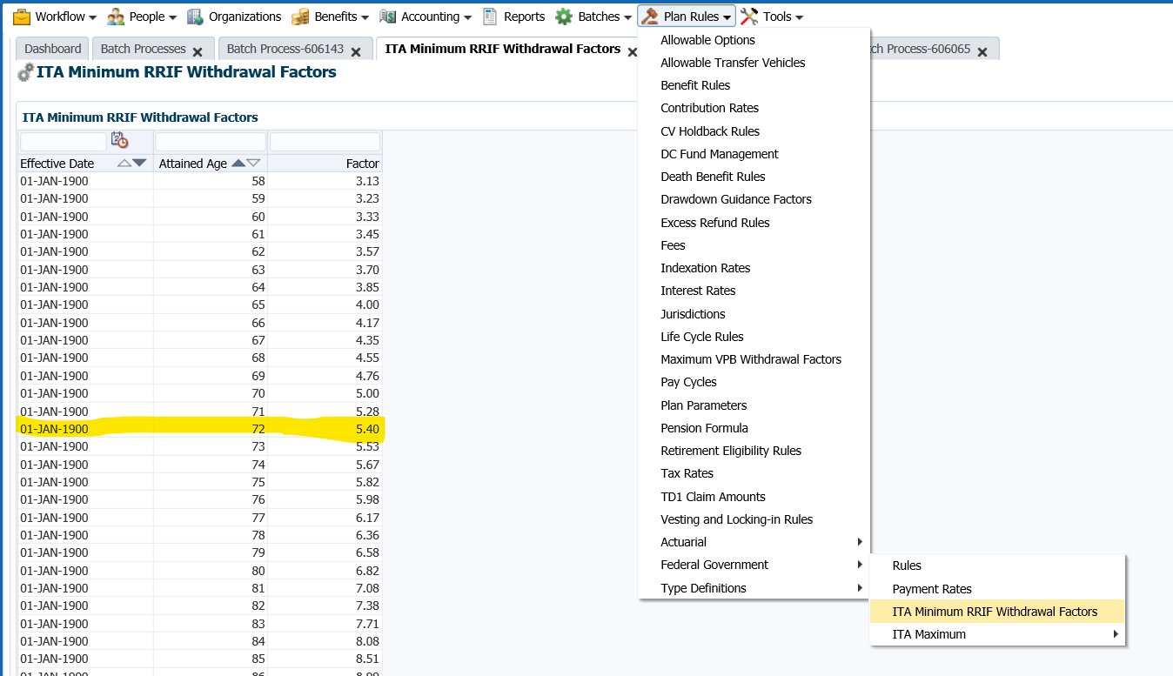

* 1. The Attained Age Factor does not match the report:

